Theme: The Media and its Power to Influence

Key Learning Points:

- Revision of the key definitions, features, and function of the Media.

- Understand how the media is a double-edged sword – that it can bring tremendous benefits, and also potential social upheaval.

- Understand that a nuanced, multi-pronged approach is needed to mitigate the potential harms brought about by media usage.

- Understand how to provide a comprehensive argument for questions with a focus on the ‘desirability’ of a subject matter.

SECTION 1. COMPILATION OF ESSAY QUESTIONS
Here is an overview of how Cambridge and other colleges have assessed students with regard to the media. You can see here that most questions focus on the following:
- The general impact / value of Media, i.e. are they beneficial, harmful, important to us?
- Whether media brings about some specific impact (e.g. empower, educate, entertain)
- Whether media platforms should be regulated / restricted in some way
Thus, our notes will focus on these areas. Please note that these focus areas are not exhaustive. It is therefore important that you research and compile your own list of the perennial and emerging issues that surround the media for your revision.

Question | Year | Source
Value-impact of Media (general)
In the digital age do newspapers still have a role in your society? | 2011 | A Level
Do we need to worry about entertainment in the media today? | 2021 | TJC
Social media has limited rather than enriched the lives of youths today. Comment. | 2021 | TMJC
Should we worry that social media has become young people’s window to the world? | 2021 | HCI
‘The most popular films are those with the least value.’ Do you agree? | 2022 | ASRJC
Value-impact of Media (specific)
Consider the argument that the main purpose of television should be to educate rather than simply to entertain. | 2015 | A Level
‘The quality of written language is being destroyed by social media.’ What is your view? | 2017 | A Level
‘Dramas on television or film are never as effective as a live performance.’ Discuss. | 2022 | A Level
To what extent are political leaders treated unfairly by the media? | 2021 | DHS
Examine the view that journalists should only report the facts and not share their opinions. | 2021 | EJC
Consider the view that having access to more information makes us more ignorant. | 2021 | MI
Consider the view that making a profit should never be the main concern of the press. | 2022 | ASRJC
‘The mass media today has focused too much on profits, and not enough on responsibility.’ Is this a fair comment? | 2022 | DHS
‘New media has transformed politics today.’ What is your view? | 2022 | CJC
To what extent does social media give power to the undeserving? | 2022 | EJC
Can the press be expected to hold the powerful to account? | 2022 | HCI
Should companies use celebrities to endorse their products? | 2022 | JPJC
To what extent has media hindered scientific progress? | 2022 | RI
Regulation of Media
Is regulation of the press desirable? | 2017 | A Level
‘In a free society, there should be no restrictions on freedom of speech.’ Discuss. | 2020 | A Level
Is greater regulation the answer to fake news? | 2019 | SAJC
Consider the claim that there should be greater control over social media. | 2020 | HCI
Should censorship of the media be entirely the responsibility of the government? | 2021 | DHS

SECTION 2. COMMON DEFINITIONS, FEATURES OF THE MEDIA – A Revision
Let us begin by understanding what the media is before we delve into its immense impact on us. Television, radio, Instagram, newspapers – all of them are examples of media platforms. How are items as different as The Straits Times and Instagram part of the same group of things called “the media”? Reading the definitions below will help you better understand the concept of “the media”.

Common Definitions:
(Mass) media
New media

Social media
Traditional media
The press | A collective term for news agencies and journalism.
Censorship | The suppression or prohibition of any parts of media that are considered obscene, politically unacceptable, or a threat to security

Types of the media:
Types
Traditional media |  | New media
Print media  Books, newspapers, magazines | Broadcast media  TV/Radio | Websites, blogs, podcasts, social media, any other mass communication occurring on a digital platform

Based on the two tables above, we see that there are different types of media platforms – traditional, new and social (which is a subset of new media). Many see internet connectivity as the key difference between the two. In the next table below, you will see how they are different in many of their features. Recall that most questions on this topic require you to argue whether, and how, the use of media platforms leads to some impact on us. Understanding these key features allows you to give a thorough explanation of how these media platforms cause those impacts. Fret not, if you do not see the link just yet. We will cover this in greater detail in Sections 3 and 4 of the notes.

Features of media (EVC) | Traditional Media | New Media
 | Print media: Only accessible to the literate  Broadcast media: More extensive reach to public through visuals | Audiences: More accessible to developed nations and those earning a middle to high income (given the need for an internet connection), although some companies offer free internet access through their media channels.  Producers: Individuals have greater access to and can release content on media platforms.
 | Print and broadcast media: Limited by number of pages and duration of programme | Vast amount of information. But some platforms may limit the information disseminated
 | Print media: Slower due to nature of printing process and news cycle | Almost instantaneous
 | Tends to be passive - audience acting as a receiver/consumer of information rather than a creator/producer | More active - audience as both a consumer of information and a producer of information. Audience is increasingly able to curate and select media that fit individual preferences
 | Largely unidirectional (information flowing from government / media organisations to general public) | Multi-directional (information flowing between individual producers and consumers);  Individual/communal (individuals gravitate towards like-minded others, forming communities online)
 | Easier to control nature of information shared | More challenging to control information shared

SECTION 3. Value of the Media

In Section 2, we introduced the features of different media platforms. Owing to these features, different media platforms have different kinds of impact on our lives. For example, the advent of new media has allowed for information to be transmitted in an engaging and interactive manner. This may have made us more engaged with the news, but it has also kept some more addicted to our devices. Going beyond engagement, we may also find that new media’s reach has also allowed us to do things that we could never have done.

In this section, we will explore the positive impact that the media has on us and also how we utilise media platforms in various aspects of lives to negotiate challenges we face in the modern world. This is also the beginning of the most important parts of this set of notes, as we have learnt on page 2 that essay questions on this topic tend to focus on the impact and value of media platforms.

Value of the Media #1: ____________________________________
The speed, reach and ease of communication on new and social media platforms facilitate the maintenance of social relationships. This is especially important in a modern world where there is an increase in movement of people across borders away from their friends and families. Coupled with increasingly hectic lifestyles, there is now a greater strain on social relationships, an integral aspect of the human experience. The rise of social media platforms promises to strengthen our bonds, thereby alleviating the strains.
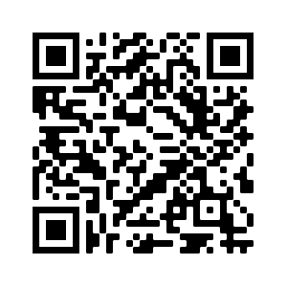
Do you know…
- 72% of Americans use social media platforms
- Facebook, a platform that allows users to connect with friends, is the most popular social media platform in the US
Scan the QR code to find out more about the social media usage habits of Americans!

Value of the Media #2: ____________________________________
The rise of independent media platforms allows well-meaning citizens and journalists to raise awareness about important social and political issues. These issues can range from health and environmental awareness to questioning of oppressive norms and criticism of injustices in the status quo. With rising rates of digital penetration today, well-meaning advocates of social change are now able to reach out to more people than ever, helping them gain supporters for social movements that change the world for the better.
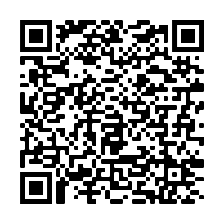
Scan the QR code to find out how social media has been used to fight gender injustice in Singapore!
Case Study
Feminism has made notable progress over the past century. However, it was really with the advent of new and social media that allowed feminists, victims, and allies to band together and upend oppressive patriarchal structures. A seminal example is the eruption of the #MeToo movement on social media. The movement was fueled by widespread allegations of sexual impropriety by Hollywood mogul Harvey Weinstein around 2017. These allegations, made on social media, went viral thanks to high profile celebrities like Uma Thurman, Jennifer Lawrence, Gwyneth Paltrow who used their influence to promote the cause. This then empowered more victims to speak up, as they now learn that they are not alone in their struggles and that they can count on public support when they do air their grievances.

The impact of (social) media activism goes beyond feminist movements. Here are some other examples of how social media has been used to resist political oppressors and corporate behemoths.
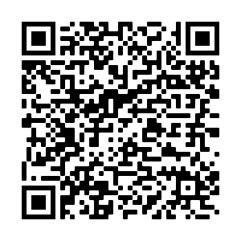

“Green influencers” harness the power of social media to tell stories about the climate to create change. Find out more here

Value of the Media #3: ____________________________________
Ever since the advent of the printing press, the media has been used as a tool to inform the masses. This is made possible by the wide reach of media platforms like television and newspaper. Through these platforms, the public is provided with the latest news updates. The introduction of new media has enhanced this function further by allowing live and timely updates that are sometimes crucial for survival in the fast-changing world we inhabit.
Example
Reflecting on the response to Hurricane Ida in 2021, emergency response officials highlighted that in addition to helping to warn residents about flooding on roads and other risks, social media was a priceless tool to quickly get information out about available resources, saving the lives of countless Americans in the process.

Beyond news updates, we also learn more about the natural and social world through engaging films, videos and television series. In this way, we learn more about cultures and pertinent issues plaguing the world. The greater accessibility of new media platforms also means that individual content creators with niche interests or experts in highly specialised fields can produce high-quality educational content. The value of such learning cannot be underestimated, especially in the globalised and crises-ridden world we live in, as they allow us to be better informed, so that we may take action and change the world for the better.

Example(s)
Documentaries like “8 Billion Angels” highlight how humanity's demand for resources vastly exceeds nature's ability to supply them. Even fictional films like Oscar winning film “Parasite” highlights the absurd consequences of unchecked inequality. On social media platforms, professionals and experts in diverse fields (e.g. VFX artists, coaches, doctors, chess grandmasters) can dive deeply into their areas of expertise to educate their audiences.

Value of the Media #4: ____________________________________
Apart from providing factual information to the viewers, the media has also been used as a tool by governments and media producers to reinforce important social norms. This is especially important in a globalised world where shared national or social values may be coming under fire. Given the modern citizens’ daily exposure to the media platforms, they have therefore become a valuable tool for those in power to safeguard these social norms.
Example(s)
The Singaporean Government has allocated about $310 million annually to support Public Service Broadcasting (PSB) programmes over the last five years. PSB programmes are to serve national and social interest objectives, including (but not restricted to): the promotion of racial and religious harmony, and the promotion of the Singapore identity.

Value of the Media #5: ____________________________________
Businesses have long been using media platforms to reach out to consumers and build awareness of their products. The rise of new and social media platforms has also empowered individuals, allowing them to reap financial benefits through word-of-mouth marketing. The deeper engagement sustained through social media platforms has allowed social media influencers and livestreamers to profit immensely, at levels that were previously unattainable by mere individuals.
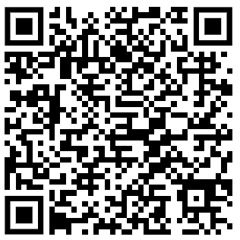
Example(s)
We are all familiar with television advertisements from major brands like L’Oréal, SK-II and McDonald’s. In the age of social media though, businesses around the world are now catching on to the potential of livestreaming to promote and sell their products. Find out more about this phenomenon here

Governments and political parties are also no stranger to the power of media platforms. Be it through traditional or new media platforms, governments have used platforms to create publicity and awareness of themselves and their policies.
Example(s)
In 2018, the Ministry of Finance collaborated with local influencers to raise awareness of the year’s Budget announcements. Major politicians, including Prime Minister Lee Hsien Loong, have also been active on social media platforms like Facebook to connect with supporters.

SECTION 4. Problems Arising from Media Usage

It seems that the media plays an essential role in our lives. In this section we will learn about how the media is a double-edged sword that can also unleash a host of problems in society.

Problem #1: ____________________________________
While social media platforms allow us to reach out and easily connect with more people, many are concerned with how these connections tend to be superficial. With social media, people are able to “befriend” two to three hundred people, with some people acquiring over thousands of people on their Friends List, although they actually lack in-depth understanding or had never even interacted with these “friends”. On social media, “to friend” someone is a fairly passive act enabled by the clicks of buttons or brought together by common interests of people who would have at most commented on similar posts—people with very casual connections who had never met in real life.
Example(s)
A study (2014) by The Pew Research Center that examined how use of social networks affected trust, tolerance, social support, and community and political engagement, revealed that about one fourth of our Facebook “friends” are at best acquaintances that we know little about, and would not have met in real life. The ease of connecting allows us to foster multiple relationships that are shallow and lacking in empathy.

Problem #2: ____________________________________
Unsupervised use of media platforms may threaten to expose users to questionable content that can corrupt their values and character. Impressionable youth, in particular, can be influenced by content such as violence, sex and offensive stereotypes⁺. This not only threatens to corrupt the values and character of youth, but can also cause problems in real life. What is particularly worrying is the trend of waning parental supervision today, compounded by the rise in dual-income families and easy accessibility to large volumes of information on media platforms.
Scan this to find out how TikTok users were encouraged to target children born in 2010 by forming an “anti-2010 police”, resulting in rise in bullying cases in France.

Socia
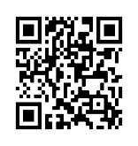
Problem #3: ____________________________________

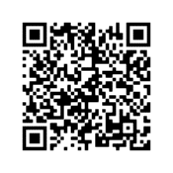
On top of that, our physical and mental well-being can take a severe blow when we are exposed to unrealistic representations of beauty and the human experience on media platforms. Given our innate propensity for social comparison and thirst for social recognition, such representations give rise to deeper insecurities and anxieties about ourselves, leading to a never-ending pursuit of ‘happiness’ (through the next product, the next diet milestone, the next vacation) that vanishes with the next advertisement or vacation photo. Given the ubiquity of mainstream and social media today, this constant bombardment on both traditional and social media platforms threaten to consign us to a miserable existence akin to a rat on a hamster wheel – always chasing, never satisfied.
Research shows that the more time people spend on Facebook and Instagram, the more they compare themselves socially. This social comparison is linked, among other things, to lower self-esteem and higher social anxiety. Scan this QR code to find out more

Problem #4: ____________________________________
The large volume of information and speed at which information is disseminated on social media makes it more challenging than ever to control online content. This means that users are exposed to misinformation and fake news, which can lead to the radicalisation of individuals. The communal nature of relation dynamics on social media also creates and reinforces echo chambers⁺, such that in-group biases are confirmed and competing views are mocked or silenced. This means that the spread of misinformation is exacerbated and destructive beliefs are further entrenched. Such radicalisation drives a wedge between groups in society, a problem especially damaging in the diverse world that we inhabit.
Case Study: Radicalisation
Social media platforms such as Facebook groups or online forums may host “echo chambers” that legitimise users’ otherwise radical or repugnant beliefs. Such validation of extreme views results in social unrest and deaths in real-life when radical beliefs are translated into actions in real-life. For example, Australian gunman Brenton Tarrant’s posted about his imminent massacre in Christchurch (which killed 51 people) on 8chan and was encouraged by users.

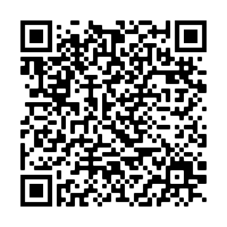
Scan the QR code to find out more!
Case Study: False information
More recently, a US report by the Office of the Director of National Intelligence revealed that Russian-liked individuals had spread “misleading or unsubstantiated allegations” about President Joe Biden ahead of the 3 November 2020 election, and that a disinformation campaign (authorised by Russian President Vladimir Putin) sought to undermine confidence in the election process. This impacts the quality of politicians and policy-making, as citizens vote based on misrepresentations of reality.

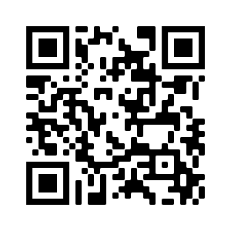
Scan the QR code to find out more!

Problem #5: ____________________________________
Corporate use of social media may have enhanced the profitability of businesses, but it is not necessarily beneficial for consumers. The fluid nature of social media and the incorporation of artificial intelligence (AI) algorithms in such platforms mean that corporations and companies can use them to predict consumers’ preferences and make use of compelling content to reach out to consumers in order to drive up sales. Such advertisements do not only affect the well-being of consumers – they can also lead to economic and environmental repercussions on society.
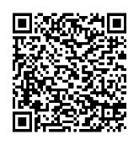
How Instagram Influencers Fuel Our Addiction to Fast Fashion. Scan the QR code to find out more!

Problem #6: ____________________________________
Given its wide reach and ubiquity in the modern society, authoritarian states and media moguls⁺ often exploit media platforms for their own gain. In such regimes, media instruments are effectively the mouthpieces of the government or powerful business owners. Through government or corporate propaganda⁺, those in control of the media brainwash the masses, keeping them compliant, ignorant, and subservient. In such cases, media platforms only serve to help the powerful, helping them maintain their exploitative rule and influence over the people.
Case Study: Media control
Chinese dissidents and activists said they feared they were being muzzled by Twitter. More than 30 prominent Chinese dissidents and activists have experienced similar visibility problems on Twitter. The activists’ accounts did not appear after a search of their Twitter names, the screenshots showed, though impostor accounts turned up. Three of the dissidents said their accounts had also been suspended with no warning and reinstated only after appeals. The issues faced by the Chinese activists’ Twitter accounts were rooted in mistakes in the company’s automated systems, which are intended to filter out spam and government disinformation campaigns

More recently, in response to foreign media’s reports about the Xinjiang cotton controversy, where China was accused of using large-scale forced labour from the Xinjiang internment camp in the production of cotton, state-run media produced their own report accusing the BBC of exaggerating restrictions placed on foreign journalists and labelling such coverage as “fake news”. Brands like Nike, H&M and Adidas were caught up in a backlash on Chinese social media after Chinese state media singled out H&M as one of the foreign brands that expressed concerns about human rights abuse in Xinjiang.

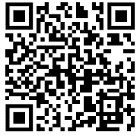
Scan the QR code to find out more!

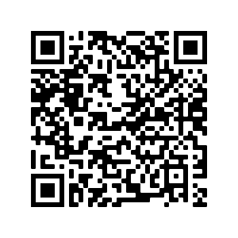
Scan the QR code to find out more!

Thinking question:
Information and communications technology developed alongside the evolution of these new media platforms. How might these advances in communications technology contribute to the value of the media in section 3? How might they worsen the problems of media covered in section 4?

SECTION 5. Solutions to the Abuse of Media
In previous sections, we learnt that the media is a double-edged sword. It can both connect and divide, educate and mislead, entertain and addict. This naturally leads to the next question: how do we reap the benefits of media platforms, while also mitigating the harms at the same time? What should the appropriate response be? In this section, we consider and evaluate the different solutions that have been tried and tested in the real world. They are:

Regulation – censorship and banning of objectionable materials
Regulation – imposition of limits (e.g. age, timing)
Education – raising the media literacy⁺ of the populace
Protests – boycotts and ‘cancelling’

This is important as we often see the following question foci in General Paper examinations:
- Should we regulate media platforms?
- What is the best solution to a given problem?
This section will give you the tools necessary to answer these questions.
Arguments for censorship / banning

Proponents of governmental control argue that media platforms need to be censored due to the immense harm it can bring to society:

[Argument #1: ____________________________________] The spread of fake news, if left unchecked, may result in disastrous consequences. On the national level, fake news can impinge upon the health of our democracy. Given that citizens require reliable information to make an informed vote on issues and politicians, the spread of fake news undermines the democratic process, leading to less informed policies. In order to secure the welfare of citizens, and to uphold the standards of democratic governance, the state should step in to regulate the media industry and censor falsehoods.
Example(s)
The Protection from Online Falsehoods and Manipulation Act (POFMA) was passed in May 2019 to protect the Singapore public against online harm by countering the proliferation of online falsehoods. Under this law, ministers can decide whether to act against falsehood on the Internet. In Jan 2020, the POFMA Office issued a general correction direction to SPH Magazines which runs HardwareZone to publish a correction notice for a COVID-related falsehood that reported the first death (a 66-year-old man) from the coronavirus in Singapore in the early days of the COVID-19 pandemic. The timely intervention ensured that falsehoods were checked to prevent panic and reduced confidence in Singapore’s effort to combat COVID-19.

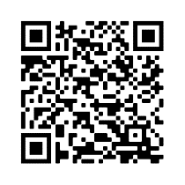
[Argument #2: ____________________________________] The surfeit of information available on the internet is a double-edged sword﹘while citizens may have easier access to information, they may also gain access to radical and subversive values or ideologies. These values (e.g. normalisation of obscenity) may threaten important public values. In more extreme cases (e.g. radical Islam / White Nationalism), these ideologies may push the citizens towards destructive acts that threaten the welfare and lives of others. Given that the protection of the rights of citizens is the raison d’etre of governments, the internet should be regulated, and radical views censored.
Scan this to find out about the EU’s new regulation, the Terrorist Content Online Regulation (adoptd in June 2021), which aggressively targets online dissemination of terrorist content.

[Argument #3: Amplify offensive remarks and threaten stability] Given the ability of media platforms to amplify offensive remarks over a short period of time, governments should legislate against such utterances. This is because these remarks can harm the psychological well-being of victims and more importantly, threaten the stability of the country.
Case Study: 2021 US Capitol Attack
The US Capitol attack that occurred in Jan 2021, following Donald Trump’s defeat to Joe Biden in the US Presidential Elections in 2020, shows how the amplification of disinformation online can lead to violence and social unrest. Incited by Trump’s tweets about irregularities of the presidential elections, pro-Trump groups on Facebook and Instagram, as well as Trump-friendly social media platforms, Trump supporters made threats like “corrupt politicians need to hang for their treason”. Inflamed supporters who eventually stormed the Capitol building live-streamed and bragged about chaos they created by the minute, while online communities shared such content and cheered on their efforts. As much as Trump was to be blamed, the social media giants like Facebook and Twitter have to be held accountable. Congressional hearings with leaders of such companies were held in the US to question why extremist voices and disinformation were allowed to proliferate on social media platforms. The problem, however, is not limited to that of social media giants but also regulation of content on smaller alternative platforms that users migrate to in avoidance of regulation, as well as traditional news outlets, like Fox News, which amplify blatant disinformation.

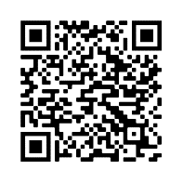
Scan the QR code to read more about the US Capitol attack & social media regulation

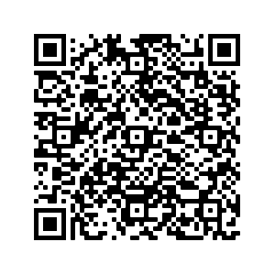
[Argument #4: ____________________________________] Governments are protectors of the well-being of their citizens. Given that media platforms may inculcate harmful habits and values (e.g. addiction, normalisation of obscenity) that threaten the well-being of the citizens, many argue that governments should step in to uphold these values.
Case Study: Regulation of video games in Australia
Australia has a rather paternalistic attitude towards video games, restricting them more than TV or film. In March 2021, video game Disco Elysium – The Final Cut was refused classification on the grounds that the game depicts “matters of sex, drug misuse or addiction, crime, cruelty, violence or revolting or abhorrent phenomena” in “against the standards of morality, decency and propriety generally accepted by reasonable adults”.
Scan the QR code to find out more!

Arguments against over-dependence on censorship / banning

But… is censorship really the panacea to all problems?

Even the most ardent advocates of free speech agree that censorship of media platforms is necessary, especially when grave harms are being threatened. However, they also argue that we should not see censorship as the silver bullet. Many free speech advocates are keen to point out that:
[Argument #1: ____________________________________] Censorship is a blunt tool – while it promises to stamp out the deleterious effects of media abuse, censoring on the basis of ‘offense’ may also prevent advocacy of progressive views that may be offensive to those who champion the status quo. On this note, we should reserve censorship only for the most extreme cases where grievous harm is threatened, and mitigate the problem of offensive views in other ways instead.
Example
History is replete with examples of how previously cherished ‘truths’ were abandoned for new paradigms, which were offensive to the believers of those ‘truths’. Helio-centricity and racial hierarchy were ideas that people fought tooth and nail to defend. Calls to ban female genital mutilation would have been offensive to cultures that practise them. Instead of protecting society, censorship only serves to stifle progress and legitimise the repugnant status quo.

[Argument #2: ____________________________________] Vesting power in the hands of the government assumes that the government is going to be a responsible arbiter of truth. Advocates of free speech argue that we would do well to remember that governments and state officials are not always benign and all-knowing. Thus, giving governments the power to determine what is the truth, or what are acceptable norms, may end up leading to the suppression of legitimate viewpoints. Giving governments too much power may then lead to an ignorant or brainwashed society where government abuses go unchecked. (See earlier examples on Media control in China (p. 10))

[Argument #3: ____________________________________] Censorship in the name of protecting public values can sometimes be illegitimate interference in the rights of autonomous adults, who should have the liberty to decide what they are allowed to express and view on media platforms as long as they are not harming others. Values differ in a modern, diverse society, and purported mainstream values should not dictate how one expresses oneself.
Example
China's broadcasting regulator, The National Radio and Television Administration (NRTA) announced in 2021 that it will ban "effeminate" aesthetics in entertainment shows. While homosexuality is not illegal, authorities are strict on censorship and edited out gay references in the Oscar winning Freddie Mercury biopic "Bohemian Rhapsody". Homoerotic plotlines between the two male leads in the hit novel “Mo Dao Zu Shi” were also removed in the TV adaptation of the novel, “The Untamed”. While such policies were made with the intention to promote public values, this move has also been criticised as yet another move that threatens to suppress diversity in the country.

In China, homosexuality is not illegal but authorities are strict on censorship and edited out gay references in the Oscar winning Freddie Mercury biopic "Bohemian Rhapsody"

[Argument #4: ____________________________________] Even if we assume that the government is benign, censoring new media platforms is like slaying a hydra﹘it requires too much physical and financial effort to constantly censor new sites that come up. This means that the government can never fully protect the citizens via censorship alone. The root cause of the problem is the citizen’s lack of media literacy, and a more practical use of public monies is to address this problem at its root, ensuring that citizens are not swayed by falsehoods and radical ideas. In fact, an overdependence on censorship infantilises the citizens as they lose the ability to think for themselves.

Having gone through these arguments, I hope you see that the answer to whether we should censor media platforms is not a simple yes/no. The better answer, is probably something like this:

While it is sometimes necessary for us to employ censorship to mitigate the problem of the abuse of media, we should be cautious of consequences of over-regulation. This is because over-regulation stifles progress, infringes on rights, and does not really address the root cause of the issue. Hence, censorship needs to be complemented by other policy tools to ensure a proportional response to the issue at hand.

So, what are these other policy tools / solutions to the problem of media abuse?

There are at least two other ways in which we can curb the negative effects of media abuse.
They are:

(A) Regulation – ____________________________________

As argued above (point 2), we need to respect the autonomy of consenting adults. At the same time, we are also worried about the influences objectionable material may have on those who are not mature enough. Hence, we can attain the best of both worlds by imposing restrictions on the access to these materials, rather than imposing a blanket ban on potentially contentious material. One common example is the imposition of age limits on films, and the policy to screen television shows meant for a mature audience only after a certain timing.

(B) Education – ____________________________________

As argued above (point 4), the key to mitigating the harms of media lies in proper education of the people. Only when the people are well-educated about the perils of media usage can they properly protect themselves by doing the relevant fact-checking⁺. This will ensure that citizens are shielded from the harms of malicious falsehoods and radical views, even when censors fail to remove all forms of objectionable content from the internet.
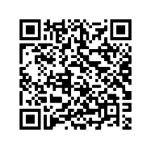
Scan this QR code to find out more about Singapore’s efforts at promoting media literacy

Another benefit of focusing on education, rather than censorship, is that it allows for rational discussion of offensive views to take place. In doing so, we do not lose the benefit of drawing potential lessons from ‘offensive’ views.
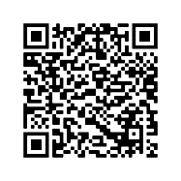
Singapore’s Protection from Online Falsehoods and Manipulation Act (POFMA) issues a correction order instead of outright censoring falsehoods, allowing the public to make the judgment for themselves. Scan to find out more.

Limitation
However, much like how censorship is not the panacea, it is dangerous to assume that media literacy programmes are fool-proof, and that people can remain fully rational even after they have gone through such programmes. Research has shown that humans are flawed beings who suffer from in-group and confirmation biases, affecting the way in which we process information. Thus, the echo-chamber effect is still a real danger, and society still needs to be proactive in weeding out the most dangerous materials.

As you see here, and in the subsequent socio-economic and political challenges, there is no singular silver bullet to the problems we are facing today. What we need is a combination of different tools that are applied according to the demands of the context and the severity of the issue. It is only then that we can reap the maximal benefits, and mitigate the harms of media platforms.

SECTION 6. KEYWORD FOCUS: Desirable / Undesirable

Common synonyms:
Desirable: good / beneficial / useful / a positive force / worthwhile
Undesirable: bad / cause for concern or worry / harmful / bad

Mass Media Questions:
- To what extent is the mass media desirable?
- To what extent is the use of social media by politicians a positive development?
- Do we need to worry about entertainment in the media today?

Questions from other topics that contain these keywords:
Is competition always desirable?

Success Criteria aka ‘How do I show that something is ‘desirable’ or ‘beneficial’?’
The word ‘desirable’ basically means attractive, good, useful, and something is good to the extent that it creates a positive impact on us or on the world.* The inverse applies to the keyword undesirable. Seen in this light, keywords in this category require you to show an understanding of how the subject matter in the question causes, or leads to some positive or negative impact, thereby making the subject matter desirable or undesirable.

- [Planning] Brainstorm for various impacts caused by the subject matter with the use of SALT.
- [Writing] Clear demonstration of how the subject matter causes the impact*
- [Writing] Clear demonstration of the significance of the impact by with reference to (why so impactful, so what):
  - Severity, Scale, Frequency
  - Features of the world
  - Essential features of humanity

*There are other ways to demonstrate desirability (e.g. demonstrating that the use of the subject promotes important moral values like rights and fairness).

Question: To what extent is the use of media platforms harmful to us?

Common Mistakes:
The student states an impact of the subject matter, but the desirability or undesirability of the impact is not properly explained. For instance, a student may argue in the following manner in response to the same question above:

Media platforms are harmful as users may end up having all of their social interactions online. This is because interactions online may be more convenient. This is problematic because when people communicate more online, they end up having less real-life interaction with each other.

This seems like it is answering the question but ______________________________________________
___________________________________________________________________________
Food for thought:
How would you make the response above better?

Sample Explanation Critique

Question: To what extent is the use of media platforms harmful to us?

[1] Our physical and mental well-being can take a severe blow  when we are exposed to unrealistic representations of beauty  and the human experience on media platforms. [2] Given our  innate propensity for social comparison and thirst for social  recognition, such representations give rise to deeper  insecurities and anxieties about ourselves, leading to a never-  ending pursuit of ‘happiness’ (through the next product, the  next diet milestone, the next vacation) that vanishes with the  next advertisement or vacation photo. [3] Given the ubiquity of  mainstream and social media today, this constant  bombardment on both traditional and social media platforms  threaten to consign us to a miserable existence akin to a rat on  a hamster wheel – always chasing, never satisfied. | Sentence 1:  Sentence 2:  Sentence 3

Essay Skills – Writing Topic Sentences That Align to the Question

Essay Question: ‘The media has made life better for all of us.’ How true is this of your society?

Key Terms | Definitions
The media | A collective term that refers to a way to communicate to a mass audience (e.g. newspapers, magazines, radio, billboards, television, social media platforms etc.)
made life better | improved life, made it easier (in different aspects of life)
all of us | Everyone
How true…your society | To consider relevance of statement in the context of Singapore society (by making reference to features of the society/ local trends etc.)

Instruction: Using relevant features of Singapore and/or features of the media provided below, craft Topic Sentences/arguments that answer the above essay question. You may use the notes to help you for this activity. A sample Topic Sentence has been provided for your reference.

Features of Singapore | Features Media
- Fast-paced/Hectic lifestyle/Little time for leisure  - Competitive  - Practical  - Pragmatic  - Ubiquity of media (mainstream and social/new media)  - Technologically-advanced/ high-tech  - Highly connected  - High internet penetration rate  - Increasingly affluent  - More people who are highly-educated  - Reliant on technology  - Value convenience and efficiency | - Ease of access/easily accessible  - Wide reach  - Volume of information  - Speed  - Engagement (active or passive)  - Challenging to control large amounts of information  - Exposure to undesirable/offensive content (a variety of different content)  - Fluid/ever-changing (content that is constantly updated or changed)  - Content created by users
Sample Topic Sentence:

In a society where people lead hectic lifestyles and have little time to maintain social relationships [SG FEATURES: address ‘your society’], the media has made life better [Stand] for us given how it enables us to widen our social circle and connect with people more easily. [Reason: why/how it has made life better for all of us]

Topic Sentence 1:

Topic Sentence 2:

Topic Sentence 3:

